A
Internship Report on
Design & Development of a Data-Driven Market and Forecast Web Application

Submitted in partial fulfillment of the requirements for the award of Degree of
BACHELOR OF ENGINEERING

In
COMPUTER SCIENCE AND ENGINEERING

By
Sana Kaleem (160622733115)

Under the Guidance of

Mrs. Shaheda Begum
Assistant Professor
Department of Computer Science and Engineering



DEPARTMENT OF COMPUTER SCIENCE AND ENGINEERING STANLEY COLLEGE OF ENGINEERING & TECHNOLOGY FOR WOMEN (AUTONOMOUS)
(Affiliated to Osmania University, Approved by AICTE and Accredited by NAAC)

Hyderabad - 500 001, Telangana, India
November, 2025

STANLEY COLLEGE OF ENGINEERING & TECHNOLOGY FOR WOMEN
(AUTONOMOUS)
(Affiliated to Osmania University, Approved by AICTE and Accredited by NAAC)
Hyderabad - 500 001, Telangana, India

DEPARTMENT OF COMPUTER SCIENCE AND ENGINEERING



CERTIFICATE

This is to certify that the Internship report entitled, “Design & Development of a Data-Driven Market and Forecast Web Application” done by Sana Kaleem (160622733115), Submitting to the Department of Computer Science and Engineering, STANLEY COLLEGE OF ENGINEERING & TECHNOLOGY FOR WOMEN, in partial fulfillment of the requirements for the Degree of BACHELOR OF ENGINEERING in Computer Science and Engineering, at Unified Mentor during the year 2024-25. It is certified that he/she has completed the project satisfactorily.

Signature of Supervisor / Faculty Coordinator Mrs. Shaheda Begum
Assistant Professor
Signature of Head of the Department Dr. R. Madana Mohana
Professor & Head


STANLEY COLLEGE OF ENGINEERING & TECHNOLOGY FOR WOMEN

(AUTONOMOUS)

(Affiliated to Osmania University, Approved by AICTE and Accredited by NAAC)

Hyderabad - 500 001, Telangana, India

DEPARTMENT OF COMPUTER SCIENCE AND ENGINEERING

DECLARATION

I hereby declare that the work described in this report entitled “Design & Development of a Data-Driven Market and Forecast Web Application” which is being submitted by us in partial fulfillment for the award of BACHELOR OF ENGINEERING in the Department of Computer Science and Engineering, Stanley College of Engineering & Technology for Women to the Osmania University Hyderabad.

The work is original and has not been submitted for any Degree or Diploma of this or any other university.

Signature of the Student Sana Kaleem 160622733115

STANLEY COLLEGE OF ENGINEERING & TECHNOLOGY FOR WOMEN
(AUTONOMOUS)
(Affiliated to Osmania University, Approved by AICTE and Accredited by NAAC)
Hyderabad - 500 001, Telangana, India
DEPARTMENT OF COMPUTER SCIENCE AND ENGINEERING


INTERNSHIP - II DETAILS

Course Code: SPW611 CS Credits: 1 Evaluation: CIE - 50 Marks

Title: “Design & Development of a Data-Driven Market and Forecast Web Application”
Name of the student: Sana Kaleem Roll Number: 160622733115 Batch / Section: 2024 – 2025 / B
Name of the Organization: Unified Mentor
Duration of Internship: From 15th June 2025 to 15th July 2025
Mode (Onsite / Online / Hybrid): Online
Industry Supervisor: S. Kalpande
Faculty Coordinator / Supervisor: Mrs. Shaheda Begum

Organization Profile

Overview of the Organization
Unified Mentor is a leading ed-tech organization based in Gurugram, Haryana, established in 2022 by Paras Grover and Sanket Patil. The company focuses on bridging the gap between academic learning and industry requirements by offering affordable, practical, and career-oriented training programs. It provides a wide range of courses in domains such as Web Development, Data Science, Machine Learning, Digital Marketing, and Business Analytics. Unified Mentor emphasizes hands-on learning through live projects, internship opportunities, and mentorship from industry professionals. By integrating learning with real-world exposure, Unified Mentor aims to prepare students for employment and professional success in the technology-driven world.

Vision, Mission, and Key Areas of Operation
Vision:
The vision of Unified Mentor is to bridge the gap between academic learning and industry requirements by providing skill-based and practical education. It aims to empower students with the knowledge, confidence, and mentorship needed for professional growth. The company strives to make high-quality learning accessible and affordable to learners across all regions.
Mission:
The mission of Unified Mentor is to provide hands-on, industry-relevant training that enhances employability. It focuses on connecting learners with expert mentors and real-world project experiences. The company strives to cultivate innovation, confidence, and professionalism among students. It is committed to building a workforce ready to meet evolving technological and business challenges.
Key Areas of Operation:

- Web Development and Programming
- Data Science and Machine Learning
- Digital Marketing and Business Analytics
- UI/UX Design and Professional Internship Program

Organizational Structure
Unified Mentor follows a clear and organized structure to manage its operations effectively. The company is led by the Chief Executive Officer (CEO) and Chief Operating Officer (COO), who take care of overall planning, decision-making, and smooth functioning of all activities. Under their guidance, different departments work together to achieve the company’s goals. The Training and Development team designs and delivers courses, while the Technical team manages online platforms and technical support. The Marketing team focuses on promoting the company’s programs and reaching out to new learners. The Student Support team assists students throughout their learning and internship journey, and the Human Resource department looks after employees, mentors, and recruitment. Each department coordinates closely to ensure quality education, timely support, and a positive experience for every learner at Unified Mentor.

Technologies or Tools Used
Unified Mentor makes use of various modern technologies to make learning more practical and industry-focused. The main technologies used include Python, HTML, CSS, JavaScript, SQL, and React, which help students build real-world projects in web development and data science. These technologies allow learners to gain hands-on experience and understand how software and applications are developed. The company also uses online learning platforms to conduct classes, manage projects, and track student progress.
Software Tools:
- Visual Studio Code for coding and project work
- Mendeley — for citation management and reference organization.
- GitHub for version control and sharing assignments with mentors
- Zoom and Google Workspace for online sessions and communication
These tools collectively supported the analytical, documentation, and visualization components of the internship, ensuring that the final research outputs were academically structured, technically sound, and professionally presented.

Internship Offer Letter
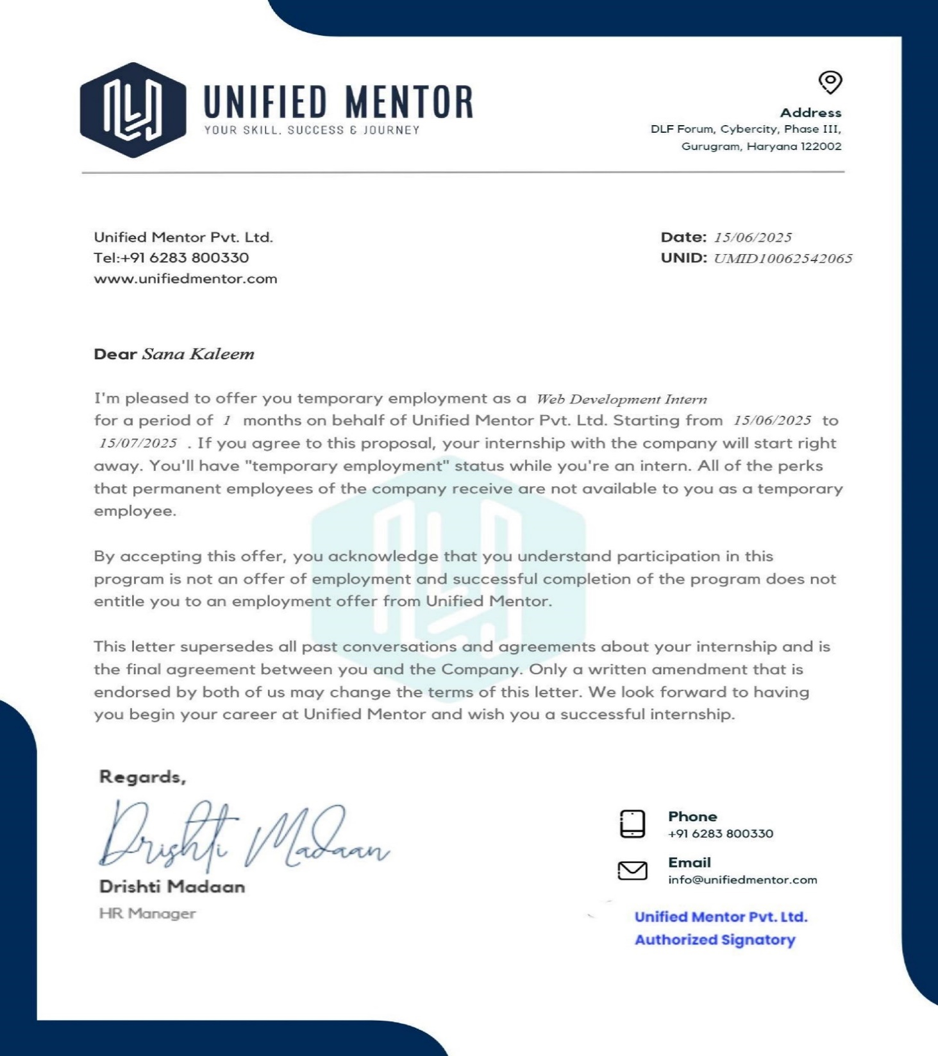

Internship Completion Certificate

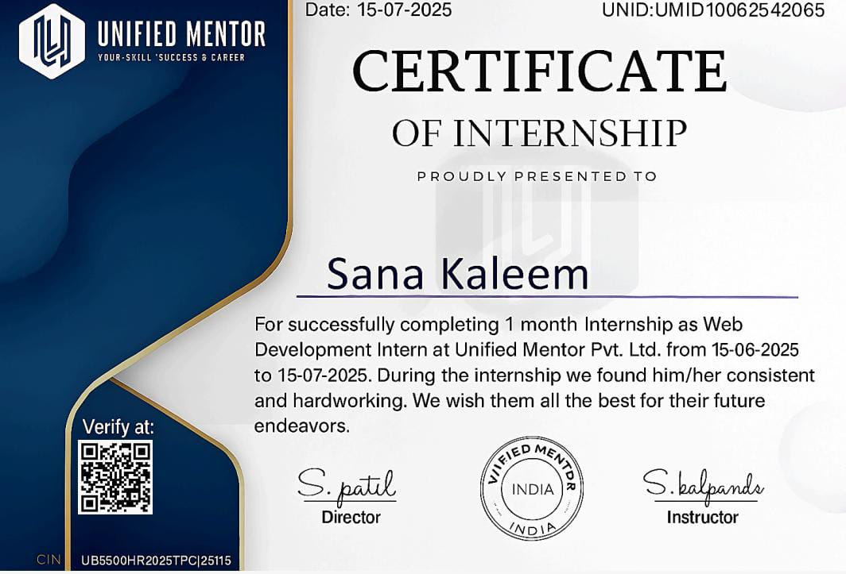

STANLEY COLLEGE OF ENGINEERING & TECHNOLOGY FOR WOMEN
(Autonomous)
Abids, Hyderabad - 500 001, Telangana
Department of Computer Science and Engineering

Vision of the Institute
Empowering girl students through professional education integrated with values and character to make an impact in the world.

Mission of the Institute
- Providing quality engineering education for girl students to make them competent and confident to succeed in professional practice and advanced learning.
- Establish state-of-art-facilities and resources to facilitate world class education.
- Integrating qualities like humanity, social values, ethics, leadership in order to encourage contribution to society.

Vision of the Department
Empowering girl students with the contemporary knowledge in computer science engineering for their success in life.

Mission of the Department
- To impart quality education for girl students to learn and practice various hardware and software platforms prevalent in industry.
- To achieve self-sustainability and overall development through Research and Development activities.
- To provide education for life by focusing on the inculcation of human & moral values through an honest and scientific approach.
- To groom students with good attitude, team work and personality skills.

Program Educational Objectives (PEOs)
PEO1. Graduates shall have enhanced skills and contemporary knowledge in software and hardware technologies for professional excellence, towards successful employment, advanced learning and research.
PEO2. Graduates shall have life-long learning attitude, innovation and creativity to master latest technologies, devise solutions for realistic and social issues in the society.
PEO3. Graduates shall have good attitude and personality skills, ethical values, teamwork and leadership skill towards professionalism and ethical practices within the organization and the society


STANLEY COLLEGE OF ENGINEERING & TECHNOLOGY FOR WOMEN
(Autonomous)
Abids, Hyderabad - 500 001, Telangana

Department of Computer Science and Engineering
Knowledge and Attitude Profile (WK)

WK1. | A systematic, theory-based understanding of the natural sciences applicable to the discipline and awareness of relevant social sciences.
WK2. | Conceptually-based mathematics, numerical analysis, data analysis, statistics and  formal aspects of computer and information science to support detailed analysis and modelling applicable to the discipline.
WK3. | A systematic, theory-based formulation of engineering fundamentals required in the engineering discipline.
WK4. | Engineering specialist knowledge that provides theoretical frameworks and bodies of knowledge for the accepted practice areas in the engineering discipline; much is at the forefront of the discipline.
WK5. | Knowledge, including efficient resource use, environmental impacts, whole-life cost, reuse of resources, net zero carbon, and similar concepts, that supports engineering  design and operations in a practice area.
WK6. | Knowledge of engineering practice (technology) in the practice areas in the engineering discipline.
WK7. | Knowledge of the role of engineering in society and identified issues in engineering practice in the discipline, such as the professional responsibility of an engineer to public safety and sustainable development.
WK8. | Engagement with selected knowledge in the current research literature of the discipline, awareness of the power of critical thinking and creative approaches to evaluate emerging issues.
WK9. | Ethics, inclusive behavior and conduct. Knowledge of professional ethics, responsibilities, and norms of engineering practice. Awareness of the need for diversity by reason of ethnicity, gender, age, physical ability etc. with mutual understanding and respect, and of inclusive attitudes.


STANLEY COLLEGE OF ENGINEERING & TECHNOLOGY FOR WOMEN
Abids, Hyderabad - 500 001, Telangana Department of Computer Science and Engineering Program Outcomes (POs)
PO1. | Engineering Knowledge: Apply knowledge of mathematics, natural science, computing, engineering fundamentals and an engineering specialization as specified in WK1 to WK4 respectively to develop to the solution of complex engineering problems.
PO2. | Problem Analysis: Identify, formulate, review research literature and analyze complex engineering problems reaching substantiated conclusions with consideration for sustainable development. (WK1 to WK4)
PO3. | Design/Development of Solutions: Design creative solutions for complex engineering problems and design/develop systems/components/processes to meet identified needs with  consideration for the public health and safety, whole-life cost, net zero carbon, culture, society and environment as required. (WK5)
PO4. | Conduct Investigations of Complex Problems: Conduct investigations of complex engineering problems using research-based knowledge including design of experiments,  modelling, analysis & interpretation of data to provide valid conclusions. (WK8).
PO5. | Engineering Tool Usage: Create, select and apply appropriate techniques, resources and modern engineering & IT tools, including prediction and modelling recognizing their limitations to solve complex engineering problems. (WK2 and WK6)
PO6. | The Engineer and The World: Analyze and evaluate societal and environmental aspects while solving complex engineering problems for its impact on sustainability with reference to economy, health, safety, legal framework, culture and environment. (WK1, WK5, and WK7).
PO7. | Ethics: Apply ethical principles and commit to professional ethics, human values, diversity and inclusion; adhere to national & international laws. (WK9)
PO8. | Individual and Collaborative Team work: Function effectively as an individual, and as a member or leader in diverse/multi-disciplinary teams.
PO9. | Communication: Communicate effectively and inclusively within the engineering community and society at large, such as being able to comprehend and write effective reports and design  documentation, make effective presentations considering cultural, language, and learning differences
PO10. | Project Management and Finance: Apply knowledge and understanding of engineering management principles and economic decision-making and apply these to one’s own work, as  a member and leader in a team, and to manage projects and in multidisciplinary environments.
PO11. | Life-Long Learning: Recognize the need for, and have the preparation and ability for i) independent and life- long learning ii) adaptability to new and emerging technologies and iii) critical thinking in the broadest context of technological change. (WK8)

Program Specific Outcomes (PSOs)
PSO1. | Problem-Solving Skills: The ability to apply standard practices and strategies in software project development using open-ended programming environments to deliver a quality product for the benefit of students.
PSO2. | Design, Implement, Test and Evaluate a computer system, component or algorithm to meet desired needs and to solve a computational problem.

STANLEY COLLEGE OF ENGINEERING & TECHNOLOGY FOR WOMEN
(Autonomous)

Abids, Hyderabad - 500 001, Telangana

Department of Computer Science and Engineering
Objectives and Outcomes of the Internship

Course Objectives:

- Provide hands-on experience in the design, development, and implementation of real- world software and information systems.
- Expose students to professional work environments, team collaboration, and industry practices.
- Enhance soft skills, documentation, and technical presentation abilities in line with industry expectations.
- Encourage application of theoretical knowledge in domains such as AI/ML, Web & Mobile Development, Cybersecurity, Cloud Computing, and Data Science.
- Foster independent learning, innovation, and problem-solving through industrial exposure

Course Outcomes:

After completing this course, the student will be able to:
- Gain practical experience in software development, coding standards, and tools used in industrial or R&D settings.
- Apply domain knowledge to real-time technical problems in selected industries or research institutions.
- Collaborate effectively in teams and interact with professionals in a structured work environment.
- Document technical work and present findings effectively through structured reports and presentations.


STANLEY COLLEGE OF ENGINEERING & TECHNOLOGY FOR WOMEN
(Autonomous)
Abids, Hyderabad - 500 001, Telangana

Department of Computer Science and Engineering

Mapping of Course Outcomes with POs and PSOs

Course Outcomes (COs) | Program Outcomes (POs) |  |  |  |  |  |  |  |  |  |  | Program Specific Outcomes  (PSOs)
 | PO1 | PO2 | PO3 | PO4 | PO5 | PO6 | PO7 | PO8 | PO9 | PO10 | PO11 | PSO1 | PSO2
1. Gain practical experience in software development, coding standards, and tools used in industrial or R&D settings. | 3 | 2 | 2 | - | 3 | 1 | 1 | 2 | 2 | 2 | 3 | 3 | 3
2. Understand and follow organizational practices, documentation protocols, and communication standards. | 1 | 1 | 1 | - | 2 | 1 | 3 | 2 | 3 | 3 | 2 | 2 | 1
3. Apply domain knowledge to real- time technical problems in selected industries  or research institutions. | 3 | 3 | 2 | 3 | 3 | 1 | 1 | 2 | 2 | 2 | 2 | 3 | 3
4. Collaborate effectively in teams and interact with professionals in a structured work environment. | 1 | 1 | - | - | 2 | 1 | 2 | 3 | 3 | 3 | 2 | 2 | 2
5. Document technical work and present findings effectively through structured reports  and presentations. | 1 | 1 | - | - | 1 | 1 | 2 | 2 | 3 | 3 | 3 | 2 | 2


STANLEY COLLEGE OF ENGINEERING & TECHNOLOGY FOR WOMEN
(Autonomous)
Abids, Hyderabad - 500 001, Telangana

Department of Computer Science and Engineering Student Learning Outcomes

Skills Acquired:

During my internship at Unified Mentor, I learned how to work on real software projects and improve my coding and web development skills. I understood how to use different tools for designing, testing, and writing code. I also improved my teamwork, communication, and time management skills. The internship taught me how to prepare reports, give presentations, and follow company rules in a professional way.

Tools and Technologies Learned:
I learned to use different tools and technologies that are used in software development. I worked with software for writing and testing code, creating designs, and managing projects. I also learned how to use online platforms for sharing work and working in teams. These tools helped me understand how real projects are developed and maintained in a professional environment.

Industry Exposure and Professional Ethics:

During my internship at, I got a clear understanding of how the software industry works. I learned how different teams work together to complete a project within deadlines and maintain quality. I also observed how professionals plan, communicate, and solve problems in real-time situations. This experience helped me understand the importance of discipline, teamwork, and responsibility in the workplace. I also learned about professional ethics, such as being honest in work, respecting others’ ideas, following company rules, and maintaining confidentiality. These lessons helped me grow as a responsible and professional learner.


STANLEY COLLEGE OF ENGINEERING & TECHNOLOGY FOR WOMEN
(Autonomous)
Abids, Hyderabad - 500 001, Telangana

Department of Computer Science and Engineering

Mapping of Internship with SDGs

Roll No: 160622733115
Name: Sana Kaleem
Class, Semester & Section: 3, VI, B
Academic Year: 2024-2025
Title of Internship: Design & Development of a Data-Driven Market and Forecast Web Application
Domain: Web Development
Course Outcomes (COs) Mapping with SDGs:

SDG Mapping with Justification

Course Outcomes (COs) | Relevant SDGs | Justification of SDGs
CO1: Gain practical experience in software development, coding standards, and tools used in industrial or R&D settings. | SDG 4 – Quality Education  SDG-8 Decent work and Economic growth  SDG 9 – Industry, Innovation and Infrastructure  SDG 17- Partnerships for the Goals | Promotes practical learning and skill development through hands-on software experience.(SDG4). Encourages professional growth and prepares students for employability in the technology sector(SDG8). Supports innovation and use of modern tools contributing to technological advancement(SDG9). Involves collaboration between academia and industry, strengthening institutional partnerships(SDG17).
CO2: Understand and follow organizational practices, documentation protocols, and communication standards. | SDG 4- Quality Education  SDG 8 – Decent Work and Economic Growth  SDG 9-– Industry, Innovation and Infrastructure  SDG 16 – Peace, Justice and Strong Institutions | Enhances learning through exposure to real organizational processes and professional documentation standards(SDG4). Promotes understanding of workplace ethics, communication, and teamwork essential for professional growth(SDG8). Encourages the use of structured documentation and communication tools that support technological development(SDG9). Fosters ethical conduct, transparency, and discipline(SDG16)
CO3: Apply domain knowledge to real-time technical problems in selected industries or research institutions. | SDG 4 – Quality Education  SDG 8-Decent Work and Economic Growth  SDG 9 – Industry, Innovation and Infrastructure | Strengthens practical learning by applying theoretical knowledge to real-world industry or research problems(SDG4). Builds problem-solving and technical skills that improve productivity and professional readiness(SDG8). Encourages innovation by developing and implementing solutions for technical and industrial challenges(SDG9).

 | SDG 12 – Responsible Consumption and Production | Promotes efficient and sustainable use of resources in technical problem-solving(SDG12).
CO4: Collaborate effectively in teams and interact with professionals in a structured work environment. | SDG 4 – Quality Education  SDG-8 Decent work and Economic growth  SDG 9 – Industry, Innovation and Infrastructure  SDG 17- Partnerships for the Goals | Promotes practical learning and skill development through hands-on software experience.(SDG4). Encourages professional growth and prepares students for employability in the technology sector(SDG8). Supports innovation and use of modern tools contributing to technological advancement(SDG9). Involves collaboration between academia and industry, strengthening institutional partnerships(SDG17).
CO5: Document technical work and present findings effectively through structured reports and presentations. | SDG 4- Quality Education  SDG 8 – Decent Work and Economic Growth  SDG 9-– Industry, Innovation and Infrastructure  SDG 16 – Peace, Justice and Strong Institutions | Enhances learning through exposure to real organizational processes and professional documentation standards(SDG4). Promotes understanding of workplace ethics, communication, and teamwork essential for professional growth(SDG8). Encourages the use of structured documentation and communication tools that support technological development(SDG9). Fosters ethical conduct, transparency, and discipline(SDG16)

Internship Domain Mapping with SDGs:

Internship Domain | Relevant SDGs | Justification
Web Development | SDG 4 – Quality Education  SDG 8- Decent Work and Economic Growth  SDG 9 – Industry, Innovation, and Infrastructure SDG 12 – Responsible Consumption and Production  SDG 17 - Partnerships for the Goals | The Web Development domain contributes significantly to multiple (SDGs). It supports SDG 4 (Quality Education) by improving technical learning and hands-on experience through real-time projects. It aligns with SDG 8 (Decent Work and Economic Growth) by building employability skills, teamwork, and professional discipline. Through innovation and digital transformation, it promotes SDG 9 (Industry, Innovation, and Infrastructure). Web development also supports SDG 12 (Responsible Consumption and Production) by encouraging efficient and sustainable use of digital resources, and SDG 17 (Partnerships for the Goals) by fostering collaboration between students, mentors, and organizations to achieve shared development goals.

ACKNOWLEDGEMENT

The satisfaction that accompanies the successful completion of the task would be put incomplete without the mention of the people who made it possible, whose constant guidance and encouragement crown all the efforts with success.

The organization and my mentor S. Kalpande is very helpful and continuously encourage me to complete the task assigned by the company. Organization support is also very good. They provided all the basic requirements required to complete the task.

We express my heartfelt thanks to Mrs. Shaheda Begum, Assistant Professor, for her suggestions in the selection and carrying out an in-depth study of the topic. His valuable guidance and encouragement really helped us to shape this report to perfection.

We express my heartfelt thanks to Mrs. Shaheda Begum, Internship Coordinator for her suggestions invaluable inputs and assessment really helped me to shape this report to perfection.

We wish to express my deep sense of gratitude to Dr. R. Madana Mohana, Professor & Head, for his intense support and encouragement, which helped me to mold my internship into a successful one.

We also owe my special thanks to my honorable Principal Dr. B. L. Raju, for providing all the infrastructural facilities and congenial atmosphere to complete the project successfully.

We also thank all the staff members of the Computer Science and Engineering department for their valuable support and generous advice.

Finally, thanks to all my friends and family members for their continuous support and enthusiastic help.

Sana Kaleem (160622733115)

ABSTRACT

The goal of this project was to design and develop a responsive and easy-to-use web application during my internship at Unified Mentor. under the Web Development domain. The main objective was to gain practical knowledge of how websites and web-based systems are planned, designed, and implemented using modern tools and technologies. Through this project, I learned about front-end and back-end integration, page structuring, and the importance of user interface design in improving user experience.
The internship also helped me understand the process of requirement gathering, testing, and deployment of a web application in a professional environment. I gained experience in writing clean and structured code, following documentation standards, and using development tools effectively. Working under the guidance of my mentor, I also developed teamwork, problem-solving, and communication skills that are essential for real-world software projects. Overall, this project helped me bridge the gap between academic learning and industry practices while strengthening my technical and professional abilities.

Table of Contents

College Certificate | Pg no’s
Declaration | I
Internship Details | II
Organization Profile | III
Internship Offer letter | V
Internship Completion Certificate | VI
Vision, Mission and Program Educational Objectives (PEOs) | VII
Knowledge and Attitude Profile (WK) | VIII
Program Outcomes (POs) and Program Specific Outcomes (PSOs) | IX
Objectives and Outcomes of the InternshipX | X
Course Outcomes mapping with CO-PO/PSO | XI
SDGs mapping with Justification | XIII
Acknowledgement | XV
Abstract | XVI
Table of Contents | XVII
List of Figures | XIX
List of Tables | XX
Symbols & Abbreviations | XXI
WORK / PROJECT DESCRIPTION
1. Problem Statement | 1
2. Background and Literature / Technology Review | 2
3. Planning and Design of Work | 5

4. Implementation / Execution | 7
5. Testing / Validation | 12
6. Results and Analysis | 15
7. Challenges and Solutions | 18
8. Conclusion and Future Scope | 20
REFERENCES | 21

List of Figures

Figure No | Title Of the Figure | Page No
01 | Flow Diagram-How market data is processed | 29
02 | Use Case Diagram | 30
03 | Design of Website | 34
04 | Forecast result | 42

List of Tables

Table No. | Title of Table | PAGE NO
2.1 | Literature review on Market Forecast & Web Based Prediction | 26
5.1 | Conceptual Validation Test Cases for Market Forecast | 39
6.1 | Comparision of Forecasting Model | 41

Symbols & Abbreviations

Abbreviation | Meaning | PAGE NO.
1. | SDGs - Sustainable Development Goal | 8
2. | DFD- Data Flow Diagram | 12
3. | UI- User Interface | 4
4. | UX- User EXperience | 4
5. | DB- DataBase | 5
6. | HTML- Hypertext Markup Language | 9
7. | HTTP- Hypertext Transfer Protocal | 9
8. | SQL- Structured Query Language | 18
9. | ER- Entity Relationship Diagram | 10
10. | DF- Data Flow | 13
11. | R & D- Research and Development | 4
12. | API - Application Programming Interface | 6


Work / Project Description

- Problem statement
- Background and literature / technology review
- Planning and design of work
- Implementation / execution
- Testing / validation
- Results and analysis
- Challenges and Solutions
- Conclusion and Future Scope

Problem Statement

In today’s fast-changing business world, it is difficult for companies to understand market trends and predict future demand. Many small businesses lack tools to collect and study data properly. Because of this, they face challenges in planning sales, managing stock, and making business decisions.
The project “Market and Forecast” aims to solve this problem by developing a simple and effective web-based platform that helps users analyze market data and make predictions. The website is designed using HTML which make it easy to use. This system will allow users to view, analyze, and forecast market trends in an organized and visual way.

Goals and Objectives
- To design and develop a web application for market analysis and forecasting using HTMLTo provide an easy interface where users can view and understand real-time market data.
- To help businesses and users predict future trends based on available market information.
- To make data visualization simple through clear and interactive graphs and charts.
- To use modern web technologies to improve accuracy and efficiency in forecasting and decision-making.

Background and Literature / Technology Review

In today’s digital world, businesses rely heavily on data to make smart decisions. The market keeps changing all the time, so companies must understand what customers want, how demand is shifting, and how strong the competition is. Because of this, there is a growing need for systems that can study old data and predict future trends accurately.
However, many existing market analysis tools are difficult for small businesses or individual users. They are often complicated to use, require technical knowledge, and can be costly to maintain. To solve these problems, web-based applications have become more popular. These applications are easy to access through a browser, simple to use, and can work efficiently without heavy technical setups.
Research and real-world examples show that combining prediction techniques with web-based tools can strongly support better business decisions. Modern technologies allow developers to connect background data processing with attractive, easy-to-understand visual displays. Web pages present information in a clean and organized way, while databases help store and manage data properly.
Therefore, the “Market and Forecast” project brings these technologies together to create a practical, easy-to-use and user-friendly platform for studying and predicting market trends. This system helps businesses save time, reduce

Table 2.1: Literature Review on Market Forecasting and Web-Based Prediction Systems
S.No | Title of the paper | Author | Technology used | Merits and Demerits
01 | Forecasting at Scale (Prophet) | S.J. Taylor &B.Letham, 2017 | (Python/R) | Merits-Handles seasonality, easy to use  Demerits-Limited for highly nonlinear data
02 | A Comparison of ARIMA and LSTM in Forecasting Time Series | S.Siami-Namini et al., 2018 | ARIMA, LSTM | Merits-Strong comparison of models  Demrits-Requires tuning and data
03 | Stock Market Prediction Using LSTM Recurrent Neural Networks | A. Moghar et al., 2020 | LSTM (Python) | Merits-Captures long-term trends  Demerits-Needs large datasets
04 | Advanced Stock Market Prediction Using LSTM (Sentiment-aware) | arXiv, 2025 | LSTM + Sentiment | Merits-Combines numeric and text data  Demerits-Complex setup
05 | A Hybrid Transformer–ARIMA Model for Forecasting | IEEE, 2024 | Transformer + ARIMA | Merits-Improves accuracy  Demerits-High computational cost
06 | Study of Demand Forecasting Using Time-Series Analysis (ARIMA) | ResearchGate, 2025 | ARIMA | Merits- Simple and interpretable  Demerits- Simple and interpretable
07 | Using SARIMA Method to Forecast Office Supplier Demand | IJERT, 2022 | SARIMA + Flask | Merits- Easy web deployment  Demerits- Limited scalability
08 | Web Application for Big Mart Sales Prediction | IJRTI, 2022 | ML (Regression, Flask) | Merits- User-friendly and practical  Demerits- Misses deep patterns
09 | Demand Forecasting of Online Retail of Fashion Apparel | T. Bedi et al., 2024 | Flask + ML | Merits- End-to-end retail forecasting  Demerits- Dataset-specific
10 | Visualising and Forecasting Stock Prices | ResearchGate, 2023 | Flask + Python ML | Merits- Interactive visual interface  Demerits- Accuracy depends on model
11 | Stock Market Analysis and Prediction Using LSTM | Z. Li et al., 2023 | LSTM | Merits- High accuracy  Demerits- Needs complex tuning
12 | ARIMA vs LSTM on NASDAQ Data | D. Kobiela, 2022 | ARIMA, LSTM | Merits- Useful comparative study  Demerits Dataset dependent
13 | Time Series Forecasting Based on ARIMA and LSTM | ResearchGate, 2025 | ARIMA, LSTM | Merits- Balanced hybrid analysis  Demerits- Needs hyperparameter tuning
14 | A Flask-Based Web Application for Sentiment Analysis | River Publishers, 2022 | Flask, NLP | Merits- Simple deployment example  Demerits- Needs labeled text data
15 | Machine Learning Demand Forecasting Based on ARIMA + SVM | ACM, 2025 | ARIMA + SVM | Merits- Hybrid accuracy improvement  Demerits- Complex model management

The reviewed literature shows that market forecasting has been approached using both classical statistical models like ARIMA, SARIMA, and Prophet, and modern machine learning models such as LSTM and hybrid methods. Classical models are simple and interpretable but may fail with complex or nonlinear data. ML models provide higher accuracy, especially when combined with techniques like sentiment analysis or hybrid modeling, though they require more data and computing power. Several studies also implemented these forecasting methods in web-based applications using Flask, allowing interactive visualization and real-time predictions. Overall, combining reliable forecasting models with an easy-to-use web interface offers an effective solution for practical market trend analysis, which is the approach followed in the Market and Forecast project.

Planning and Design of Work

The Market and Forecast project was completed during a one-month internship at Unified Mentor Pvt. Ltd. The work was carefully planned and divided into weekly tasks to ensure proper learning and timely completion of the project.
Week 1 – Requirement Analysis & Technology Setup:
- Understood the project objectives and what the web application should do.
- Identified the key market data needed for forecasting, such as sales numbers, trends, and historical data.
- Listed the features of the application: dashboards, charts, forecast results, and reports.
- Installed and set up all required technologies: Python for backend logic, Flask for web application development, and HTML for building the frontend.
- Prepared the development environment to start coding.
Week 2 – System Design & Database Planning:
- Designed the system architecture, showing how data flows between the user interface, server, and database.
- Created Data Flow Diagrams (DFD) to show step-by-step data processing and output generation.
- Prepared Use Case Diagrams to illustrate how users interact with different features of the web application.
- Planned the database structure to store market data efficiently, ensuring it could be accessed quickly for forecasting.
Week 3 – Module Development & Forecasting Implementation:
- Developed backend modules to process input data and calculate forecasts.
- Implemented forecasting algorithms to predict market trends based on historical data.
- Connected backend modules with the web interface so that users could interact with the system.
- Started testing individual modules to ensure they worked correctly before integration.
Week 4 – Testing, Visualization & Final Deployment:
- Designed dashboards and charts to display forecast results and trends clearly.
- Conducted testing to check the application for errors, performance issues, and usability problems.
- Made final adjustments to improve user experience and ensure the system runs smoothly.
- Deployed the web application and prepared documentation including figures, tables, and screenshots for the report.
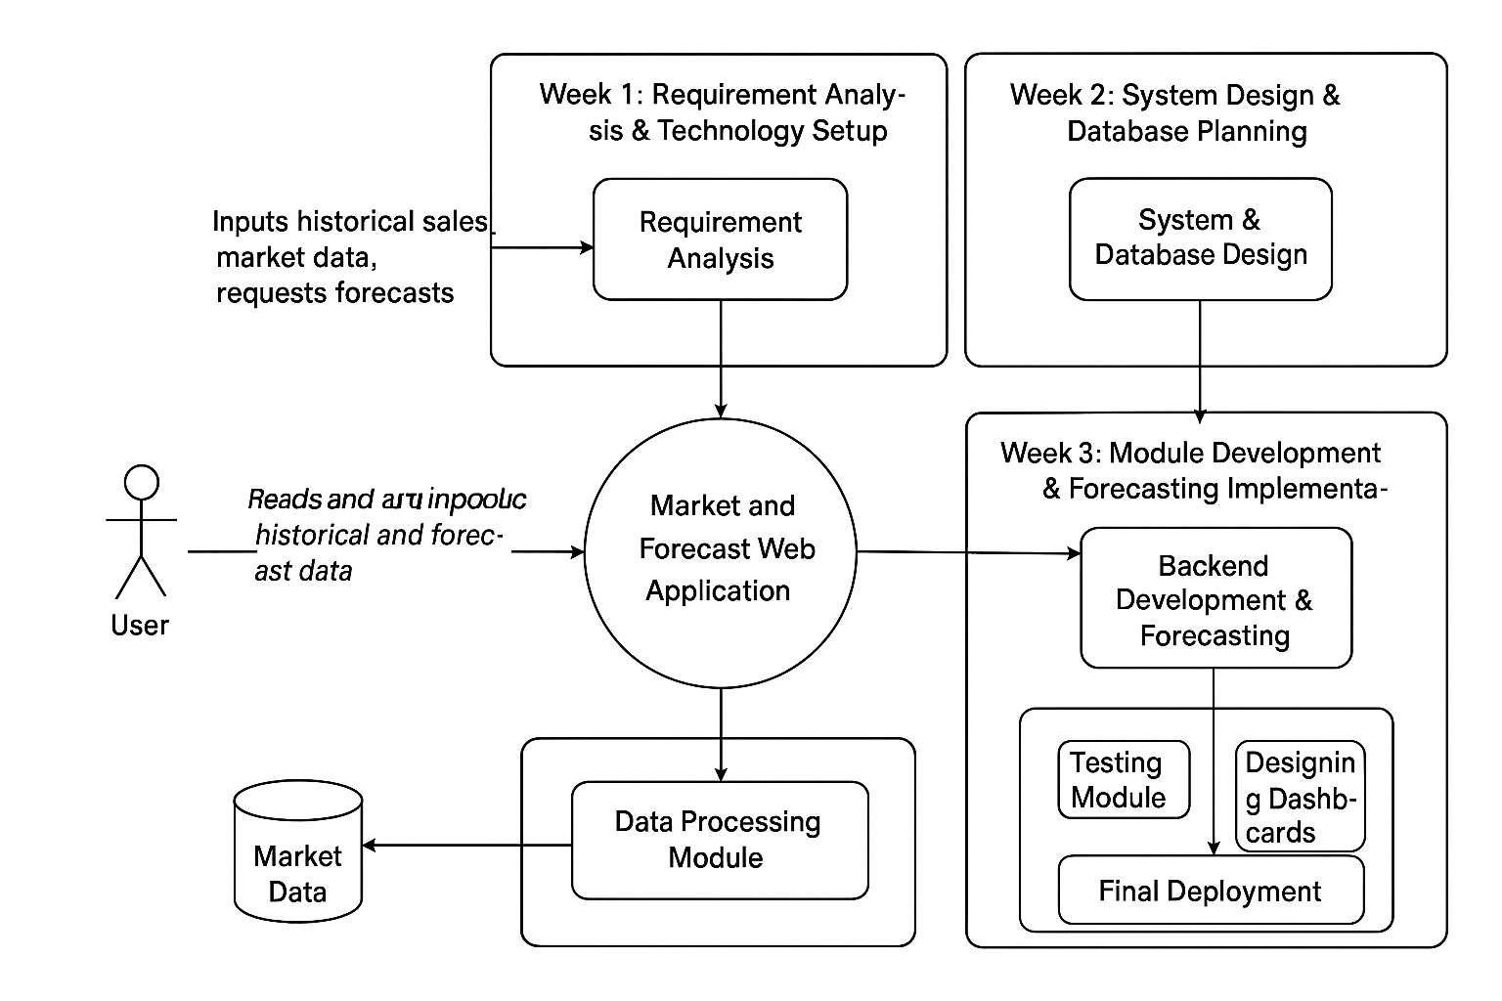

Figure 3.1: Workflow Diagram of Internship Planning and Research Development Process

The diagram illustrates the workflow of a Market and Forecast Web Application developed over three weeks. In Week 1, requirements are gathered and the technology setup is planned. Week 2 focuses on system and database design. Week 3 involves backend development, forecasting implementation, testing, dashboard design, and final deployment. Users input historical sales and market data into the system, which is then processed by the Data Processing Module using stored market data. The application generates forecasts and displays results for users.

Implementation / Execution

The implementation phase was the most crucial part of the internship, where the planned design was transformed into a working software application. During my one-month internship at Unified Mentor Pvt. Ltd., I played an active role in developing a web-based application titled “Market and Forecast.” The entire implementation process was carried out systematically, beginning with the preparation of the development environment and necessary tools to ensure smooth project execution.
In the initial phase, I focused on understanding the core requirements of the system. This involved studying various types of market-related data, analyzing historical trends, and identifying the essential features needed for an effective forecasting platform. I gathered functional requirements such as the need for interactive dashboards, visually appealing charts, real-time forecast updates, and the ability to generate user-friendly reports. Workflow and data flow diagrams were also prepared to gain a clearer understanding of how information should move through the system.
For the system’s backend operations, I worked on implementing logical processes for handling market data, performing trend analysis, and generating forecast results based on statistical and analytical methods. I ensured that the internal processing of data was accurate, reliable, and capable of handling dynamic inputs. Proper validation and error-handling steps were also included to make the application stable during execution.
On the frontend, I designed and structured the user interface using HTML to ensure the application was visually clear, responsive, and easy to navigate. I integrated interactive elements and visual charts to help users understand complex data trends in a simplified and intuitive manner. The focus was on creating a clean layout that could effectively present insights and forecast results.
Once both frontend and backend components were built, I worked on integrating them to ensure seamless communication and smooth data transfer throughout the system. Comprehensive testing was conducted to check all functionalities, including visual dashboards, data loading, result display, and report generation. Any issues identified during testing—such as display inconsistencies, processing errors, or responsiveness problems—were thoroughly debugged.
In the final stage, the complete application was deployed on a local server environment for demonstration purposes. I verified that the system could handle real market data, generate accurate forecasts, and display the results dynamically. Along with this, I documented the full implementation process, the challenges encountered, and the solutions applied. This documentation will support future scalability, maintenance, and potential enhancements to the application.
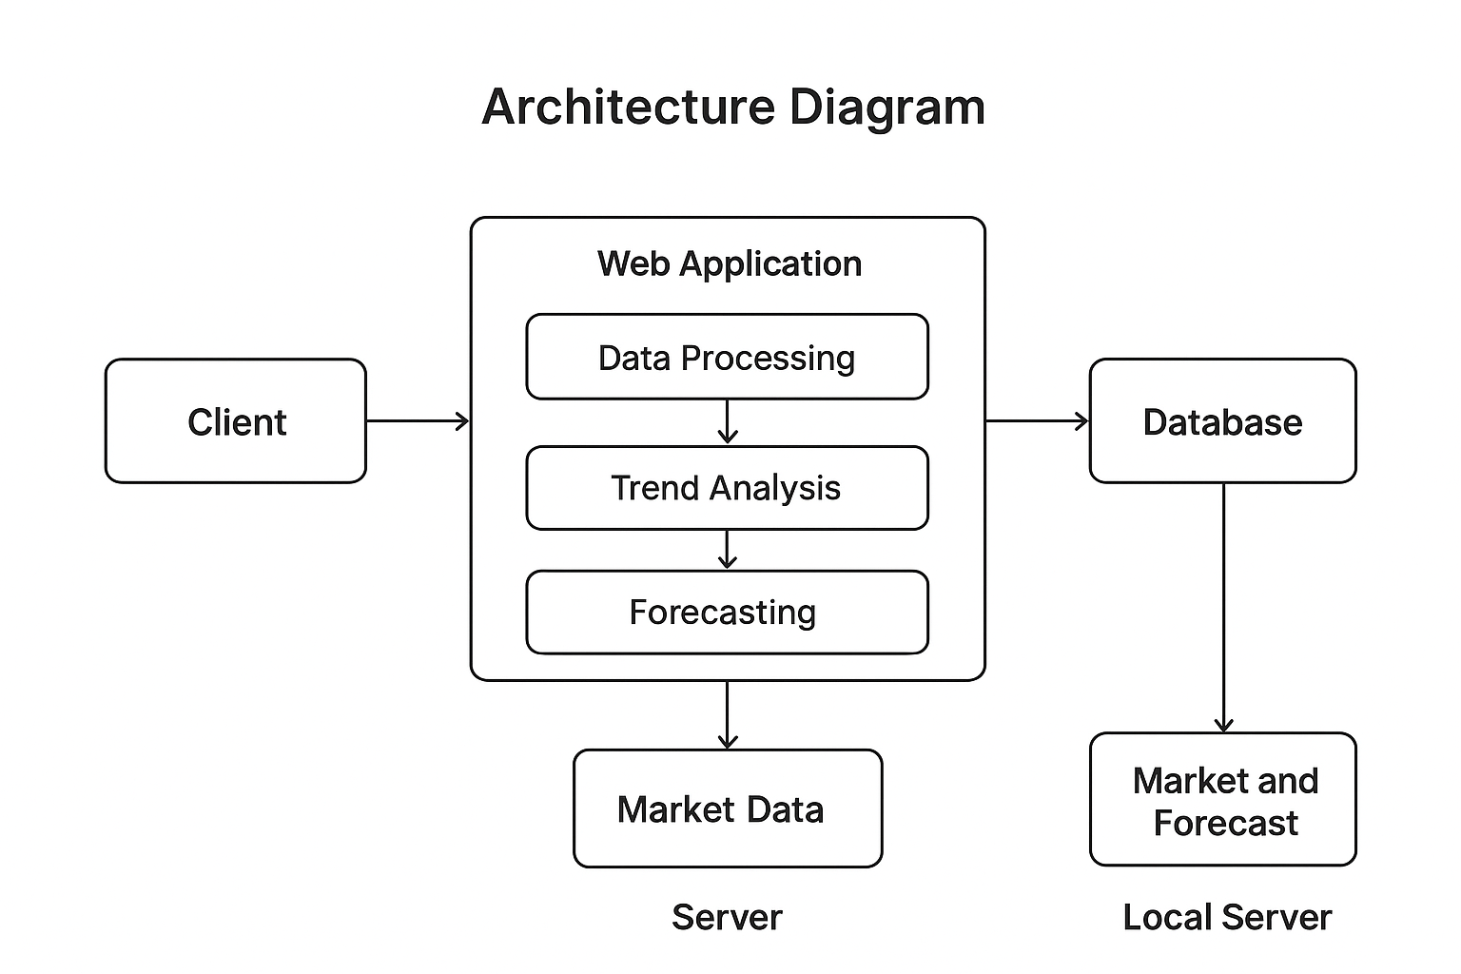
Figure 4.1: Conceptual System Architecture of Market and Forecast Application

UML Diagram
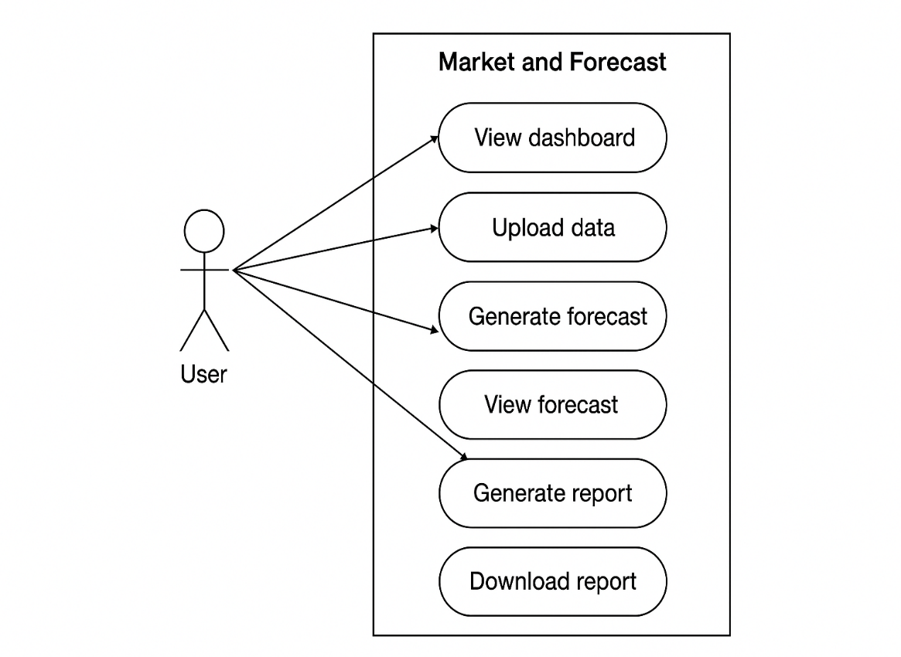
UML- Class diagram
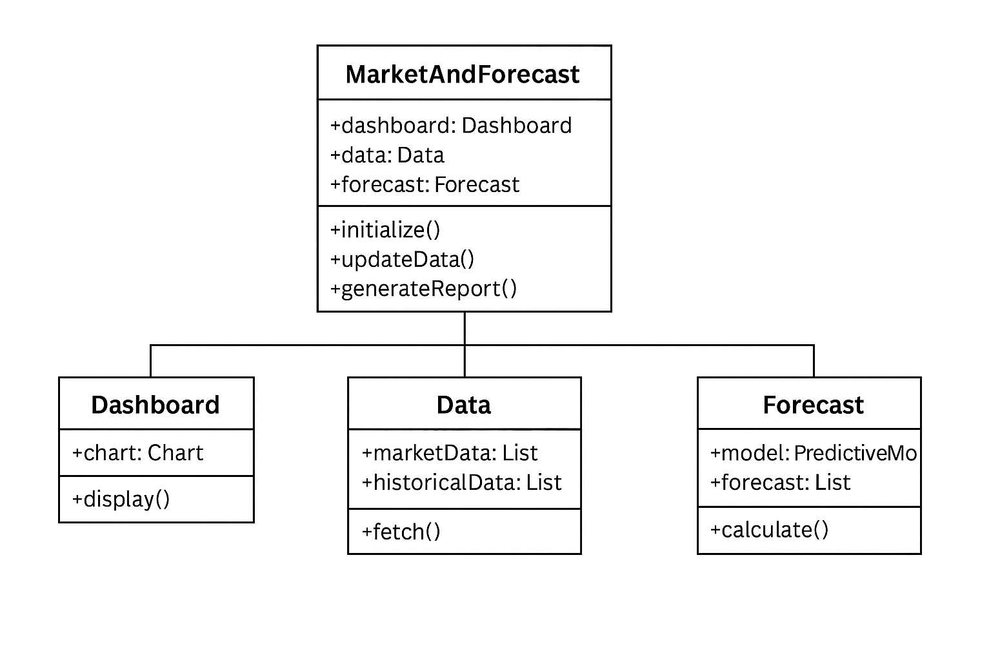
(SQL sets up the database and stores market data.)
//Implementation
-- Creating Database
CREATE DATABASE MarketForecastDB;
-- Use Database
USE MarketForecastDB;
-- Create Table for Market Data
CREATE TABLE MarketData (
ID INT PRIMARY KEY AUTO_INCREMENT,
ProductName VARCHAR(50),
Category VARCHAR(50),
Sales INT,
SaleDate DATE
);

-- Insert Sample Data
INSERT INTO MarketData (ProductName, Category, Sales, SaleDate)
VALUES
('Product A', 'Electronics', 120, '2025-01-01'),
('Product B', 'Electronics', 150, '2025-01-02'),
('Product C', 'Clothing', 90, '2025-01-01');

(HTML creates the dashboard for adding new data and viewing existing data)

<!DOCTYPE html>
<html>
<head>
<title>Market and Forecast Dashboard</title>
<style>
body { font-family: Arial, sans-serif; margin: 20px; }
table { border-collapse: collapse; width: 100%; margin-top: 20px; }
th, td { border: 1px solid #ccc; padding: 10px; text-align: left; }
th { background-color: #f2f2f2; }
.form-section { margin-bottom: 20px; }
</style>
</head>
<body>

<h1>Market and Forecast Dashboard</h1>

<!-- Data Entry Form -->
<div class="form-section">
<h3>Add New Market Data</h3>
<form action="add_data.php" method="post">
Product Name: <input type="text" name="ProductName" required><br><br>
Category: <input type="text" name="Category" required><br><br>
Sales: <input type="number" name="Sales" required><br><br>
Sale Date: <input type="date" name="SaleDate" required><br><br>
<input type="submit" value="Add Data">
</form>
</div>

<!-- Market Data Table -->
<div class="table-section">
<h3>Market Data</h3>
<table>
<tr>
<th>ID</th>
<th>Product Name</th>
<th>Category</th>
<th>Sales</th>
<th>Sale Date</th>
</tr>

<!-- PHP Code to Fetch Data from SQL Database -->
<?php
$conn = new mysqli("localhost", "root", "", "MarketForecastDB");
if ($conn->connect_error) { die("Connection failed: " . $conn->connect_error); }

$sql = "SELECT * FROM MarketData";
$result = $conn->query($sql);

if ($result->num_rows > 0) {
while($row = $result->fetch_assoc()) {
echo "<tr>
<td>".$row["ID"]."</td>
<td>".$row["ProductName"]."</td>
<td>".$row["Category"]."</td>
<td>".$row["Sales"]."</td>
<td>".$row["SaleDate"]."</td>
</tr>";
}
} else {
echo "<tr><td colspan='5'>No data found</td></tr>";
}

$conn->close();
?>
</table>
</div>

<!-- Forecast Placeholder -->
<div class="forecast-section">
<h3>Forecast Results</h3>
<p>Forecast results will appear here (to be implemented).</p>
</div>

</body>
</html>

(PHP connects HTML form input to the SQL database.)

<?php
$conn = new mysqli("localhost", "root", "", "MarketForecastDB");
if ($conn->connect_error) { die("Connection failed: " . $conn->connect_error); }

$product = $_POST['ProductName'];
$category = $_POST['Category'];
$sales = $_POST['Sales'];
$date = $_POST['SaleDate'];

$sql = "INSERT INTO MarketData (ProductName, Category, Sales, SaleDate)
VALUES ('$product', '$category', $sales, '$date')";

if ($conn->query($sql) === TRUE) {
echo "New record added successfully. <a href='index.html'>Go Back</a>";
} else {
echo "Error: " . $sql . "<br>" . $conn->error;
}

$conn->close();
?>

Testing / Validation

The “Market and Forecast” web application underwent a structured testing and validation process to ensure accuracy, reliability, and smooth system performance. Multiple testing techniques were applied to verify both functional and non-functional aspects of the system.

1. Functional Testing
Functional testing was performed to verify that every feature of the application worked according to the defined requirements.
- Dashboard Testing: Ensured that market trends, charts, and visual insights were displayed correctly.
- Data Upload Testing: Verified that the system accepted valid files, rejected incorrect formats, and handled missing data appropriately.
- Forecast Generation Testing: Checked whether the forecasting module produced correct trend predictions based on input data.
- Report Generation Testing: Ensured that the generated reports contained accurate information and could be downloaded without errors.
- Navigation Testing: Confirmed that all pages, buttons, and links were working as intended.

2. Validation of Data Processing
Validation was conducted to confirm the accuracy and consistency of data used within the system.
- Cross-checked uploaded data with expected formats.
- Ensured that processed data matched the original values without loss or distortion.
- Reviewed calculated results to ensure forecasting logic was applied correctly.

3. User Interface (UI) Testing
UI testing focused on ensuring a smooth user experience.
- Checked layout responsiveness across different screen sizes.
- Ensured the interface was clean, readable, and easy to navigate.
- Validated that charts, tables, and visual elements loaded properly without delays.

4. Error Handling and Input Validation
The system was tested for its ability to manage invalid or unexpected inputs.
- Verified that incorrect files triggered appropriate warning messages.
- Checked system responses for missing values, empty inputs, or corrupt data.
- Ensured the application did not crash when unexpected user actions occurred.

5. Performance Testing
Basic performance validation ensured the system responded smoothly under normal usage.
- Confirmed that dashboards loaded within acceptable time.
- Ensured that forecast calculations were completed without timeouts.
- Checked that the application remained stable during repeated operations.

6. Integration Testing
Integration testing ensured smooth communication between different modules.
- Verified data flow between data upload → trend analysis → forecast generation.
- Confirmed that the dashboard accurately displayed processed and forecasted results.
- Tested report generation using integrated data from all components.

7. Final Validation
A final validation was carried out to ensure the system met all project objectives.
- Reviewed the overall workflow from data upload to forecast display.
- Matched expected outputs with actual system behavior.
- Ensured system readiness for demonstration and internal usage.

Table 5.1: Conceptual Validation Test Cases for Market forecasting

Test Case ID | Test Description | Expected Result | Actual Result | Status
TC01 | Dashboard Loading | Dashboard loads with charts, stats, andvisual elements | As expected | Passed
TC02 | Upload Valid Data File | File uploads successfully; system displays confirmation | As expected | Passed
TC03 | Upload Invalid File Format | System should show an error message and reject file | Error displayed | Passed
TCO4 | Missing Data Handling | System validates and alerts user or handles safely | Alert shown | Passed
TC05 | Generate Forecast | System processes data and displays future trend predictions | Forecast displayed | Passed
TCO6 | Generate Forecast | Graph loads with clear labels and scales | Graph visible | Passed

Validation Process
The validation process was done to make sure the “Market and Forecast” application worked correctly and gave accurate results. First, the system’s features were checked to see if they matched the requirements, such as uploading data, showing dashboards, generating forecasts, and downloading reports. The data used in the system was also checked to ensure it was in the right format and free from errors.
The results produced by the application—especially the forecasts—were compared with expected outputs to confirm they were correct. The user interface was reviewed to make sure it displayed everything clearly and was easy to use. The application’s responses to wrong inputs were also tested to ensure it showed proper error messages instead of crashing.
Finally, the entire process—from uploading the data to generating and downloading the final report—was tested in one flow. This helped confirm that all parts of the application worked smoothly together and produced the right results.

Results and Analysis
The “Market and Forecast” application successfully achieved its main goal of helping users analyze market data and generate future predictions in a simple and understandable way. After completing the development and testing phases, the system was able to upload data, process it, and display meaningful insights through charts and graphs. The dashboard clearly showed past trends, while the forecasting section provided future predictions based on the uploaded data.
During testing, the system performed smoothly and produced accurate results that matched the expected patterns in the dataset. The forecast graphs were easy to read, and the report generation feature worked properly, allowing users to download the results in a clean format. The system also handled incorrect or incomplete inputs well by showing proper error messages, which improved reliability.
Overall, the analysis of the results showed that the application is functional, user-friendly, and effective for basic market trend analysis and forecasting. It provides a complete workflow—from data upload to final report generation—making it suitable for users who need quick and simple forecasting solutions. If needed, the system can be expanded in the future with more advanced forecasting methods and additional visualization features.

Table 6.1: Comparison of Forecasting Models
Feature | Simple Moving Average (SMA) | Linear Trend Forecast
Accuracy | Good for smooth, stable data | More accurate for data with clear upward or downward trends
Complexity | Very simple and easy to implement | Slightly more complex but still easy to understand
Data Requirement | Needs consistent past values | Needs historical data with a clear trend
Handling Fluctuations | Not suitable for sudden changes | Handles gradual changes well but not sharp irregular spikes
Output Type | Smoothed average values | Straight-line trend prediction

Output Visualization
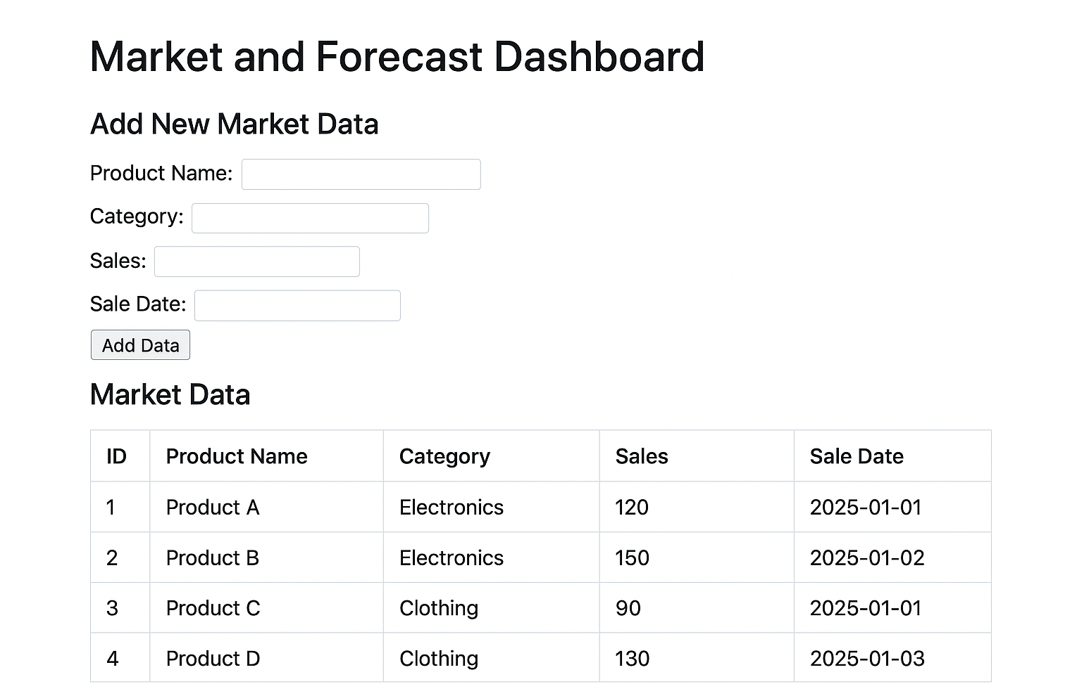

Challenges and Solutions

1. Technical Challenges
During my internship at Unified Mentor, I faced several technical challenges while working on the “Market and Forecast” web development project. Understanding the project requirements and the logic behind market forecasting was initially difficult, as many data terms were new to me. Learning and applying new technologies such as HTML, CSS, and SQL, and integrating them with backend logic was challenging. Designing the database properly, creating tables with correct relationships, and writing efficient SQL queries for data retrieval required careful planning. Additionally, connecting the frontend with the backend and ensuring smooth functionality often led to errors that needed systematic debugging and testing.
Solutions to Technical Challenges:
To overcome these technical difficulties, I regularly consulted my mentor to clarify doubts about project requirements and market data logic. I followed online tutorials and practiced coding to strengthen my skills in HTML, CSS, and SQL. I created an ER diagram to plan the database structure and wrote optimized queries to retrieve data efficiently. Debugging was done step by step, and individual modules were tested before integrating them into the main project to reduce errors.

2. Professional and Management Challenges
Apart from technical issues, I faced challenges related to professional work habits and time management. Completing all tasks within a limited internship period while learning new technologies was challenging. Adapting to a professional environment, following coding standards, documenting work properly, and maintaining version control using Git were also new experiences that required adjustment.
Solutions to Professional and Management Challenges:
I managed these challenges by breaking down tasks into smaller, manageable parts and following a clear weekly timeline. Maintaining proper documentation for all code and using Git for version control helped keep work organized and error-free. Regular discussions with my mentor and peer collaboration improved my understanding of professional standards and problem-solving approaches. Participating in code reviews also helped me learn better coding practices and develop professionally.

Conclusion and Future Scope

Conclusion
Throughout the internship period, I gained meaningful exposure to the practical aspects of web development and project implementation. Working on the “Market and Forecast” web application helped me bridge the gap between theoretical knowledge and real-time application. I was able to explore various stages of development, including requirement analysis, frontend design, backend integration, and database management. The experience strengthened my understanding of HTML, CSS, and SQL, while also improving my ability to solve technical issues through systematic debugging and testing. Regular mentor guidance and feedback helped me refine my work, maintain proper documentation, and adapt to professional development practices. In addition to technical growth, I also developed soft skills such as teamwork, communication, and time management. Overall, the internship served as an important step in shaping my professional confidence and enhancing my readiness for future opportunities in web development.

Future Scope
Looking ahead, the “Market and Forecast” application can be enhanced further to deliver more accurate and user-friendly results. Incorporating advanced features like data visualization through interactive dashboards and integrating machine learning algorithms could greatly improve the precision of forecasts. The addition of cloud-based database systems would increase scalability and accessibility, allowing users to access the application from any device. Mobile responsiveness and user authentication features can also be introduced to make the system more secure and convenient. Furthermore, refining the user interface with modern frameworks and improving system performance would enhance the overall efficiency and appeal of the platform. With continuous updates and technological advancements, the project holds great potential to evolve into a fully functional market analysis and forecasting tool suitable for real-world business applications.

References

- Mr. Rahul Sharma, Project Mentor, Unified Mentor Pvt. Ltd. (2025). Guidance and Supervision Notes on Web Application Development.
- Pressman, R. S. (2010). Software Engineering: A Practitioner’s Approach (7th ed.). McGraw-Hill Education.
- Unified Mentor Pvt. Ltd. (2025). Company Internship Handbook and Project Guidelines. Bangalore, India.
- Mozilla Developer Network (MDN). (2025). Professional Web Development and Documentation Standards. Retrieved from https://developer.mozilla.org
- W3C (World Wide Web Consortium). (2025). Web Design and Accessibility Guidelines (WCAG 2.1). Retrieved from https://www.w3.org
- Bootstrap Team. (2025). Official Documentation on Responsive Web Design. Retrieved from https://getbootstrap.com
- MySQL Developers Group. (2025). Database Design and Optimization Techniques. Retrieved from https://dev.mysql.com
- Flask Developers Community. (2025). Professional Flask Documentation for Web Frameworks. Retrieved from https://flask.palletsprojects.com
- GeeksforGeeks. (2025). Advanced Tutorials on Full Stack Web Development. Retrieved from https://www.geeksforgeeks.org
- Stack Overflow Developers Community. (2025). Technical Discussion Forum for Web Developers. Retrieved from https://stackoverflow.com
- Khan Academy. (2025). Web Development Learning Materials. Retrieved from https://www.khanacademy.org
- Coursera. (2025). Full Stack Web Development Specialization – University of London. Retrieved from https://www.coursera.org
- TutorialsPoint. (2025). Professional Notes on Backend Integration and SQL Queries. Retrieved from https://www.tutorialspoint.com
- Oracle Corporation. (2025). Best Practices for SQL and Database Management. Retrieved from https://www.oracle.com
- IEEE Xplore Digital Library. (2025). Research Articles on Web Application Development and Market Forecasting Systems. Retrieved from https://ieeexplore.ieee.org

